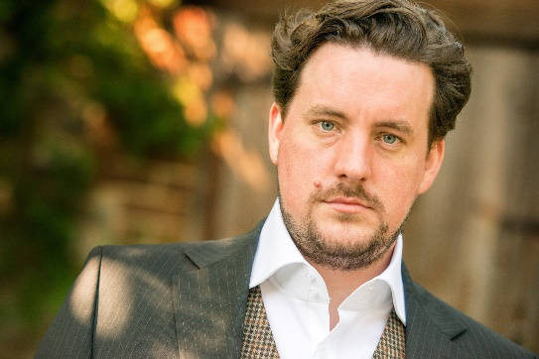
Benedict Nelson
Baritone

British baritone Benedict Nelson, was an inaugural Harewood Artist with English National Opera. His recent highlights include Henry Cuffe in Britten Gloriana for Teatro Real in Madrid and Orff’s Carmina Burana with the Gulbenkian Orchestra as well as Donnacha Dennehy’s acclaimed The Second Violinist for Irish National Opera at the Barbican.
At ENO his roles included Valentin Faust, Demetrius A Midsummer Night’s Dream, Belcore The Elixir of Love, Count The Marriage of Figaro, Figaro The Barber of Seville, Ping Turandot, Evangelist/Watchful/First Shepherd The Pilgrim’s Progress and the title role in Billy Budd.
Nelson has gone on to make acclaimed performances as Algernon Moncrieff in The Importance of Being Earnest at Royal Opera House, Aeneas Dido and Aeneas at the Teatro Regio di Torino as well as the Salzburg Festival, the Verbier Festival and in Wiesbaden. He has also performed Ned Keene Peter Grimes for Opéra de Lyon and Opera North, Silvano Un ballo in maschera for Opera Holland Park, Don Giovanni for Silent Opera, Marcello La bohème, Sid Albert Herring and Tarquinius The Rape of Lucretia for Angers Nantes Opera.
On the concert platform he has performed Stranger The Lady from the Sea for Scottish Opera and Edinburgh International Festival and Melot and Steersman Tristan und Isolde in concert with the City of Birmingham Symphony Orchestra, Vaughan William’s Sea Symphony with the Royal Scottish National Orchestra and Bournemouth Symphony Orchestra, Walton’s Belshazzar’s Feast, Brahms’ Ein Deutsches Requiem with the Hallé, Britten’s Noye’s Fludde with La Maîtrise de Radio France, and Weill’s Das Berliner Requiem with L’Orchestre Philharmonique de Radio France.
Nelson’s current and upcoming engagements include The Burning Fiery Furnace for Scottish Opera at Lammermuir Festival and Athropocene, also with Scottish Opera. He will also perform again in the The Second Violinist on a tour to Amsterdam with performances at the Concertgebouw, and then New York in 2019, as well as title roles in Monteverdi’s Il ritorno d’Ulisse in patria on a tour across the United States with Circa Contemporary Circus.
His recordings include Britten’s Songs and Proverbs of William Blake with Malcolm Martineau, recorded live at the Cheltenham Festival for Onyx.

2018-2019 season. Not to be altered without permission.

